**Modification of area to equalize the Recycling collection workload** **and**

**Vehicle routing problem**

**한국외국어대학교 산업경영공학과**

This paper approached the problem found in the existing recycling collection management and present a scientific alternative to solve it. The existing recycling collection area was established based on the administrative area divided by the boundaries of the map and the collection route was established by workers with knowledge of the location of the collection area. However, this system has made a difference in workload among workers. Moreover, since the route was created by the worker's sensitivity within the allotted collection area, the task becomes inefficient for those who is unfamiliar with geography or for the complicated area. These sometimes lead the company to pay extra wages and could further be extended to the problem of city cleanliness. Therefore, we defined the standard workload first to calculate the workload in the collection area and established new one also considering the adjacency of it for the convenience of management. And we found a route closer to the optimal route by using the Heuristic algorithm within the newly established collection area. Finally, we implemented it as a system to manage and visualize the path.

**Index**

I. Introduction 4

II. Related Research 8

III. Analysis Framework 9

Ⅲ. A Data Acquisition 9

Ⅲ. B Data preprocessing using GIS 10

Ⅲ. C Data analysis for Predictive Modeling 13

Ⅲ. D Algorithm 15

Ⅲ. D. (1) Zone Modification 15

Ⅲ. D. (2) Mathematical Model 16

Ⅲ. D. (3) Modification the Route 17

IV. Data Analysis 19

Ⅳ. A Zone modification 19

Ⅳ. B Modification the Path 20

V. Conclusion 22

* **Figure Index**

Figure 1. Waste recycling performance 4

Figure 2. Framework 6

Figure 3. Definition of Arc and Node 7

Figure 4. Split Line 11

Figure 5. Far away from the center lines 11

Figure 6. Left – Original GPS Point, Right – Modified GPS Point 11

Figure 7. Multiple Point Case 12

Figure 8. Single Point Case 12

Figure 9. Left - Delaunay Triangulation, Right - Voronoi diagram 15

Figure 10. Modification Zone 19

Figure 11. Dividing zones based on administrative districts 19

Figure 12. Compare RT between Xpress MP and Algorithm 20

Figure 13. Screen for the route 21

* **Graph Index**

Table 1. GPS Data Information 9

Table 2. Neural Network Analysis Accuracy 14

Table 3. Compare result between Xpress MP and Algorithm 20

# Introduction

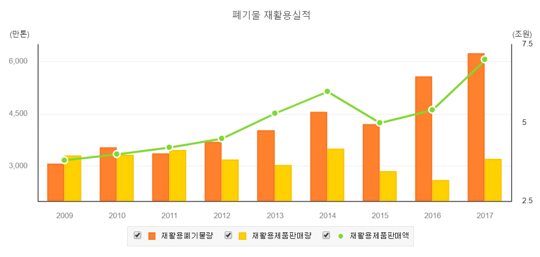 In Korea, refer to the data of the Korea Environment Corporation's "Waste Recycling Performance and Business Status."

Figure 1. Waste recycling performance

As shown in the figure, the amount of recycled waste has been increasing steadily since 2009. As a result, the importance of the recycling waste disposal problem is also highlighted. The issue of recycling waste collection is of great concern to residents as it greatly affects the cleanliness, convenience and satisfaction of their local and residential lives. On the other hand, however, the recycling collection status has not changed much from the past. The previous recycling waste collection method was carried out by hand mainly under the jurisdiction of the local government. The collection area was divided based on the boundaries of the map, and within the area, the collection route was established based on the workers' experience to be collected. Currently, there is little difference from the past except that local governments have signed contracts with private companies and entrusted them with collection work. However, this approach creates a number of problems.

First, workers who are overworked due to workload differences among workers are complaining when the area is divided based on administrative district. However, because of the fact that tasks cannot be assigned in smaller units based on administrative district, the alternative is to allow less-worked vehicles to move to a completely different area for collection. This is a very inefficient operation because it takes a lot of movement time as well as moving expenses. Second, if the area is divided in this way, the collection service may not be carried out smoothly if the area is relatively large, or in areas with different administrative districts, even in adjacent areas, recycling waste may not be collected. Third, as the collection takes place within an assigned area, new employee will take more hours to work than existing workers. As mentioned earlier, private companies have recently taken over collection services from local governments, which include wages for regular working hours only. Therefore, the payment of wages for additional working hours is solely borne by the company, which results in losses to the company if additional work occurs. Fourth, there is no systematic data collection and system establishment of recycling collection system, which makes it difficult to increase and manage efficiency of the collection system.

The purpose of this paper is to establish systematic criteria to obtain data and to reduce worker complaints by modification the collection area so that the workload is similar among workers. Also, under these divided collection zones, the vehicle route is modified to the nearest optimum to secure available vehicles and available personnel. Finally, by building it into a visual system, it helps to facilitate the supervision of the task manager. Also provides visual route that are close to optimal for those who are not familiar with the geography, making it easier to grasp the task and use the working time efficiently. Ultimately, by using resources efficiently, better collection services will be provided to improve the quality of the residential environment.

To do this, we first defined the definition of collection points and workload. More systematic criteria and data was established using the Geographic Information System (GIS). We gathered the data from the digital topographic map provided by the National Geographic Information Service for road centerline and building information data and from 'National Waste Statistical Survey Report' provided by the Environmental Agency for the application unit information and finally from the National Statistical Office site for statistical data on the number of residents and employees.

In this study, Giheung-gu in Yongin City was used as a case in order to modify recycling waste collection area and route. Giheung-gu was judged that it is appropriate to generalize research based on this area as apartment complexes, residential areas, farming areas, forests, and new towns are mixed within Yongin City. In addition, the location of Giheung-gu and the laboratory is close, making it fluid to collect and analyze data periodically.   
 Currently, there are a total of six vehicles collecting recycling waste from Giheung-gu, mostly capacitated by 2.5 tonnes. All recycled waste is handled except plastic bags, and unloading place of waste is located in Cheoingu. In most areas of Yongin City, recycling waste collection placed in front of each building by using a door-to-door collection method, and worker separately load Styrofoam and the rest of the recyclables into a vehicle.  
 This study can be largely divided into three stages: First, obtaining data about the recycling waste collection workload. Second, dividing the area base on this data for the equality in the workload. Third, modification of the route in this area as near an optimal route. It can be divided into six stages for more detail. The first is to obtain data using the GPS, digital topographic map, emission unit, and GIS with the Data Collection. Second, we defined the new definition of workload and process data, calculate workload and estimate emissions based on the data obtained. Third, to establish a workload prediction model through regression, clustering analysis, and neural network analysis based on processed data. Fourth, the dividing recycling waste collection area based on the equivalence of the workload, and the fifth is to find a collection path that is close to the best within the modified collection area. Finally, we 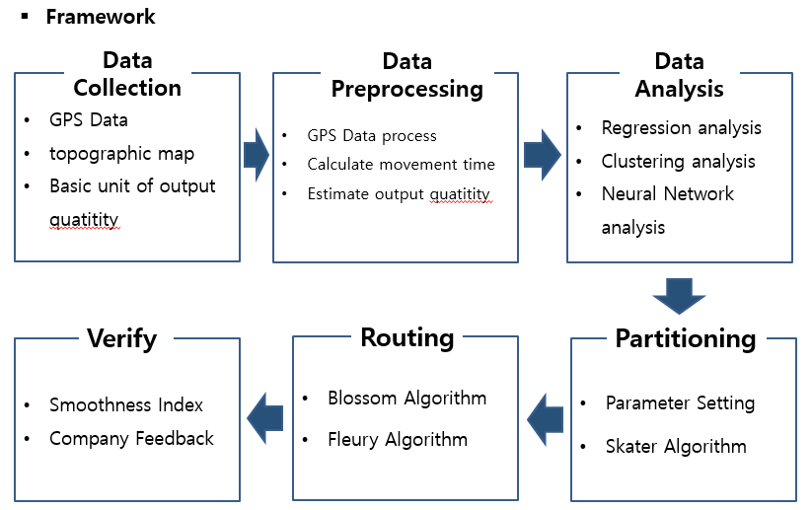have verified the effect.

Figure 2. Framework

To define the criteria for nodes and arcs prior to this study, the nodes were set as the intersection of the road centerline and the arc was set as the line connecting the nodes. It is actually correct to set all buildings as nodes, but the number of nodes would be so large that it would take a huge time or impossible to derive a good solution or it would be less likely to produce a good solution, so we had to reduce the number of nodes and arcs.

Figure 3. Definition of Arc and Node

**Arc**

**Node**

**Node**

The problem of modifying the route of recycling waste collection vehicles is belong to the problem of routing, which is divided into Node Routing and Arc Routing. In the case of Node Routing, the optimal route is to find path that pass all nodes which results in an arc that does may not be passed. On the other hand, the Arc Routing problem is a matter of finding the best route passing all arcs at least once. In the case of waste collection problems, Arc Routing rather than Node Routing was considered suitable for this problem as it must pass through all arcs near the building. The problem was defined as the Undirected Chinese Postman Problem based on two-way traffic because of the limitations of obtaining accurate data on one-way and two-way traffic

In this study, we conducted four hypotheses.

1. In the digital topographic map, which is the basis of the data, only arcs in the apartment with the data are used because they contain only a fraction of the arc inside the apartment.
2. If you go to the collection place of waste to empty the loaded recycled waste, assume an average of 3.4 times and 72 minutes per session based on GPS data.
3. Differences exist between the arc data in the digital topographic map and the arc data on Google Maps, which may seem like an error in the system.
4. When dividing zones to equalize the workload, it was not taken into account to return to and from the unloading area.

In this study, the SKATER algorithm was used to reset the collection area, using modules built into ArcGis software and Googlemap Api to visualize the reset collection path.

# Related Research

Studies on the routing of garbage collection vehicles have already been actively studied abroad. Among them is a study that incorporates a mathematical model and a GIS, which allows decision makers to analyze many alternatives before deciding on the final scenario (NB Chang, 1997) and there is a study considering a case that has to consider multi unloading place because of the limitation of the capacity of the unloading place and because of the distance between the collection and unloading place and a study considering the mealtime for the worker .(BI Kim, 2006)   
 Among the methods for establishing a collection zone is the division of area method, which divides the target area into the number of areas required, but is a solution that can maximize density of each zone while meeting the marginal conditions of adjacency and zone size (He-Yeon Lee, Eun-Sun Im, 2001), but research on waste collection areas for balancing the work load has yet to be actively studied. In addition, studies on recycling waste collection systems are not actively conducted, although systems that collect general waste and systems that collect recycling waste vary slightly in workload estimates and collection methods. Therefore, the purpose of this study is to modify the collection area by considering the adjacency of the collection area and the equivalence of the workload, taking into account the convenience of the worker's labor and the task manager's supervision. This is expected to have the effect of increasing the efficiency of the work and reducing the work deviation. As the matter of modifying the route for recycling waste collection vehicles, Status of work has actually been observed on a regular basis for a long time at the work site, and we found out that many of them have been collected while moving. Rather than simply using the amount of garbage collection, which is an indicator of the workload of existing garbage collection tasks, the movement time between nodes was used as the basis for calculating the workload as a new workload indicator considering the number of work, collection volume and time. In addition, the problem was defined as the Undirected Chinesse Postman Problem among Arc Routing Problem, which requires all arcs to be passed at least once, since all recycling wastes on the roadside must be collected. The expected effect of this is producing routes systematically rather than the geographical experience of workers, which is the traditional method of calculating work routes will be much shorter than previous ones and will be a good indicator of work even for those who do not know the geography. Ultimately, quality of environmental cleanliness services in cities is expected to be improved by efficient use of resources.

# Analysis Framework

## Ⅲ. A Data Acquisition

The most important data in modification waste collection areas and routes is the collection time of waste by arc. However, because there is no data base built, GPS is attached to the vehicle every 12 seconds to analyze the current operational status and analysis of Giheung-gu in Yongin, the area under analysis. A total of six vehicles collect recycled waste from Giheung-gu, and an average of 1,200 GPS data was accumulated per day over six days to collect a total of 43,200 data and build a database. The information available through GPS includes the route, distance, travel time, travel speed, latitude and longitude.

Table 1. GPS Data Information

|  |  |
| --- | --- |
| **Section** | **Contents** |
| **Number of vehicle** | **6 vehicle** |
| **Number of data** | **6 vehicle * 1200 * 6day = 43,200** |
| **Start date** | **April 23, 2018** |
| **End date** | **April 28, 2018** |
| **Attitude** | **GPS Point number,**  **IN Time, OUT Time,**  **distance, Speed,**  **latitude, longitude** |

In addition, a database of various independent variables should be established to establish a predictive model for estimating future road collection times. The independent variables considered in this study were waste estimated emissions, length, number of lanes, road width and number of adjacent buildings for each arc. In order to estimate waste emissions by arc (Lee Hee-yeon, 2001), data on unit emission information provided by the Environmental Agency and the number of residents and employees of the National Statistical Office were collected to establish emission data for each arc. Next, through digital topographic maps, data on the length, number of lanes, and width of road, information related to roads were built.

## Ⅲ. B Data preprocessing using GIS

One of the purposes of this study is to equalize the workload, which requires a criteria measure to calculate the workload. Measurements that can be considered include estimated emissions, arc length, arc travel time, number of buildings around the arc, number of lanes, and road width. It was determined that the volume and weight of recycled wastes were not proportional and difficult to measure, and that the number of arc roads, lanes, and road width were not sufficient to represent the workload. Therefore, all of the data were processed accordingly, including all of the above concepts, with measures that best represent the current situation set to arc travel time. The program used for pretreatment is ArcGIS.

First, we removed the noise that existed in the data obtained earlier. For example, in digital topographic maps, for road lines that are away from the road center line, all lines were removed because the collection vehicle was not allowed to enter, and broken lines were merged again. In addition, nodes were created at the intersection of the road centerlines, and even though they had the same coordinates, a different node number was created for each arc connected so that four node numbers existed at the intersection. However, because routing using algorithms requires having one node number in one coordinate, Python was used to integrate all the coordinates so that only one node number was present.

Figure 4. Split Line

Figure 5. Far away from the center lines

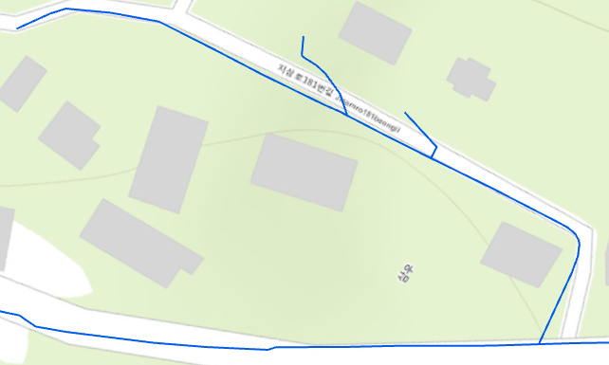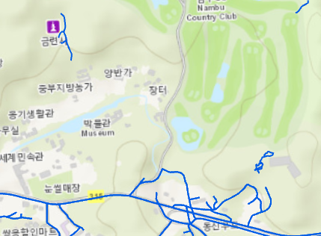

Second, data accumulated through GPS attached to the vehicle were processed to calculate the collection time by arc. The disadvantages of GPS are not to record the exact location of the road the vehicle has passed, but because it has a 5 to 20 meter error radius and is recorded anywhere within that radius, it is actually recorded near the route the vehicle passes through. But in order to calculate the collection time, GPS records must be aligned on the road. Therefore, GPS points were aligned on the road using the functions in the program and GPS information was transferred to the road center line through spatial join. Next, the collection and travel time of arc was calculated by dividing the single point with one GPS point in one arc and the multiple point with two or more GPS points in one arc. The arc's stamped GPS points created the vehicle's route and then cut it back to the node to calculate the arc's travel time.

Figure 6. Left – Original GPS Point, Right – Modified GPS Point

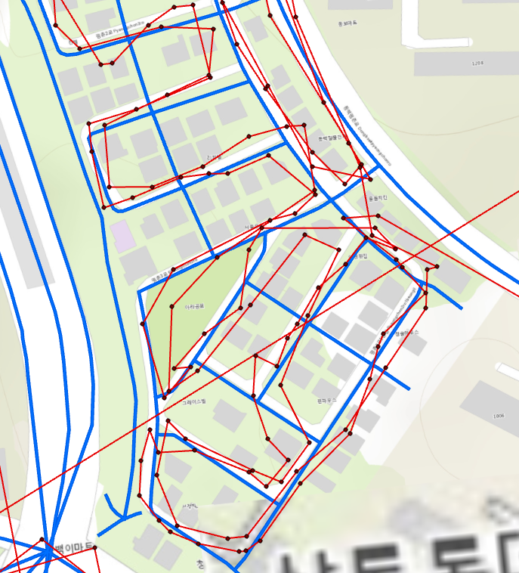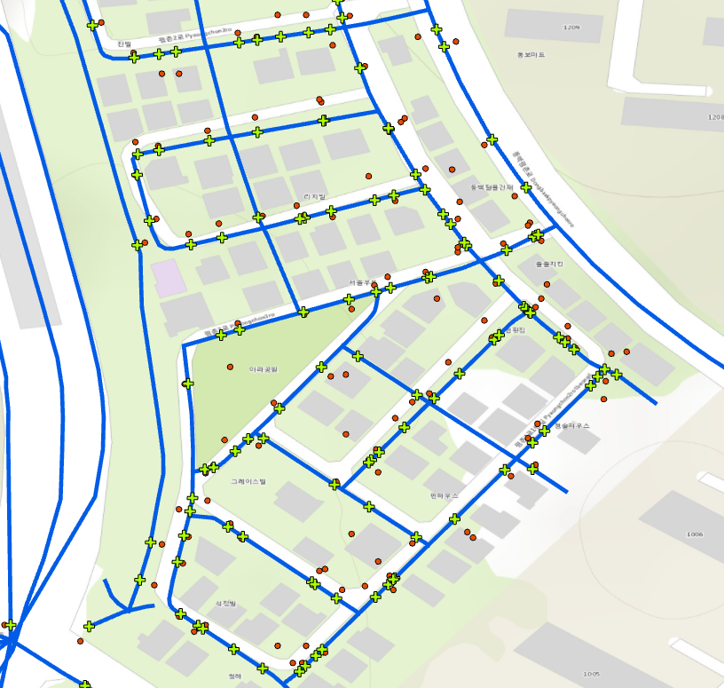

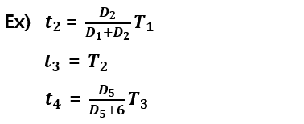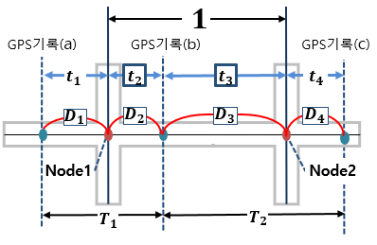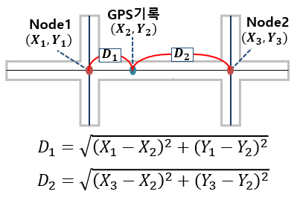

Figure 7. Multiple Point Case

Figure 8. Single Point Case

Third, estimated emission by arc and number of buildings data were established. Currently, the National Statistical Office has aggregated data based on the respective administrative statistics, but does not have data for waste emission at each emission point. There are several methods for estimating emissions, but in this study, the research method of Lee Hee-yeon & Lim Seon (2001) was used. This method estimates daily emissions by emission point by multiplying the average number of people in each building by unit emission. To do this, the buildings are first divided into housing and business, and the average number of residents per house is weighted, and the business is to apply weight to the average number of workers per building. For emission units, use reports provided by the Environmental Protection Agency. The weights and emission units are then calculated to add data on emissions estimates to the building information via ArcGIS and calculate total estimated emissions by arc through spatial join. During the spatial join, a buffer of 22 m was formed in the arc and performed, and data on the number of adjacent buildings in each arc can be built as well this process.

## Ⅲ. C Data analysis for Predictive Modeling

Since Yongin is an area under active development, new roads will continue to be created in addition to the data collected for research. Thus, statistical analysis was conducted to establish a model for predicting the collection time of new roads for efficient work distribution and collection. Priorities normalized the values of all variables to make them the same indicator.

First, a regression analysis was performed to find out the factors affecting arc collection time. Dependent variables are collection time from arc or moving speed from arc, and independent variables are set as estimated emission, arc length, number of lanes, road width and number of buildings around arc. Regression analysis performed is as follows.

1. Dependent variables are travel time in arc and independent variables are estimated emission amount, arc length, lane number, road width, and number of buildings near the arc to conduct a Multiple Regression Analysis.
2. Dependent variables are the moving speed in arc and independent variables are estimated to be the amount of emissions, arc length, lane number, road width, and number of buildings near the arc, and then Multiple Regression Analysis is performed.
3. Dependent variable is the travel time in arc, it is performed separately with independent variables.
4. Dependent variable is the moving speed in arc and it is performed separately with independent variables.
5. Divide the number of lanes by the number of lanes, put the dependent variable into the moving time in the arc, and conduct a separately Simple Regression Analysis with the independent variables.
6. After dividing by the number of lanes, insert the dependent variable at the speed of travel in the arc and conduct a separate Simple Recession Analysis with the independent variables.

The regression analysis determines that a significant linear model was formed when the adjusted R square value was 0.7 or more, but the analysis above showed that the adjusted R square value was less than 0.2 and thus no significant results were obtained.

Second, to calculate the collection time by predicting the moving speed in the arc, the moving speed was divided into four sections to perform a clustering analysis. The results conducted using Twostep and K-means showed good quality of the classed clusters, but they were not suitable as a method for forecasting because they were not clearly classified for independent variables with low predictor importance.

Thirdly, neural network analysis was performed to predict the time of waste collection in arc. Neural network analysis conducted is as follows.

* 1. Set all independent variables in a continuous format and perform neural network analysis with the target (dependent variable) collection time.
  2. Set all independent variables as continuous format and perform neural network analysis with target moving speed
  3. The independent variables are sorted by the 20th, 10th, 5th, and distribution, and the target is put into the moving speed and perform neural network analysis.

Similarly, neural network analysis determined that an accuracy of about 70% or more should have resulted in a significant predictive model, but all of the analysis results were significantly lower and did not form a significant model. This is because arc collection times are affected by many other variables, the data obtained in this study determined that it would be difficult to build a predictive model.

Table 2. Neural Network Analysis Accuracy

|  |  |
| --- | --- |
| **Parameter** | **Accuracy** |
| continuous format | 0% |
| sorted by the 20th | 8% |
| sorted by the 10th | 18% |
| sorted by the 5th | 31% |
| sorted by distribution | 12% |

## Ⅲ. D Algorithm

### Ⅲ. D. (1) Zone Modification

First, the purpose of modification the recycling waste collection area is to ensure equal work load among workers, and thus should be divided by workload and number of workers. In addition, areas adjacent to each other should be combined to allow for easier management of the task manager. In other words, the entire workspace should be divided into adjacent areas and based on the number of workers, vehicles and working days defined so that the workload can be equal. For this purpose, SKATER Algorithm was used to divide data with similar values for the characteristics of interest into spaces and form clusters. The detailed description of this algorithm is as follows.

SKATER Algorithm (Spatial “K”luster Analysis be Tree Edge Removal Algorithm)

1. The data with similar values for the characteristics of interest are divided into spaces to form a cluster
2. Using the Delone triangulation method and Boronoy diagram, a graph is created to obtain spatial similarity and proximity

* Delaunay Triangulation
  + - When the points above the plane are connected by a triangle to divide the space, Division to ensure that the minimum value of the inner angle of these triangles is maximized.
  + Voronoi diagram
    - a diagram of areas divided by which points on a plane are closest to which pi.
  + Voronoi diagrams can be obtained by connecting the center of the circumscribed circle of the Delaunay triangles, adjacent if they have a common side on the Boronoy diagram.

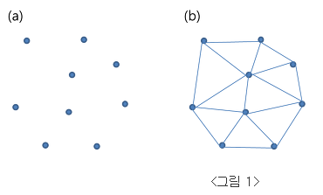

Figure 9. Left - Delaunay Triangulation, Right - Voronoi diagram

1. Based on the graph created, create a minimum spanning tree to calculate spatial similarity based on the distance from the seed point.
2. Graphs are divided to maximize spatial similarity
   * + Constraints: The sum of the values of each node should not exceed the value set in max.

### Ⅲ. D. (2) Mathematical Model

Due to the characteristic of recycling waste collection tasks, waste on all roads within the collection area should be collected. Therefore, all arcs must pass at least once, and minimizing the total cost (time) is at the core of this problem. At this point, in order to check the minimum cost, mathematical model is set as below.

Objective Function – Minimize total movement time

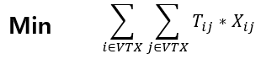

Decision Variables

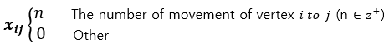

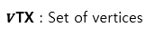Set

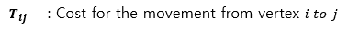Parameter

Constraint

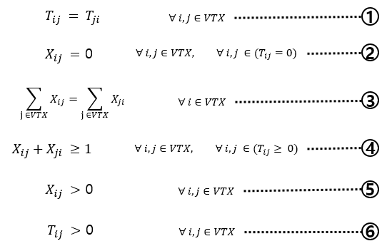

1. The distance is the same regardless of the direction.
2. We cannot go where there is no real road.
3. The degree of entering and leaving the vertex is the same.
4. Every side has passed at least once.
5. Nonnegative constraint
6. Nonnegative constraint

### Ⅲ. D. (3) Modification the Route

Earlier, a recycling waste collection vehicle must pass all arcs at least once, and a mathematical model has been established to find the optimal value of minimum cost. Based on the company and collection criteria, the total collection area was divided into 18 areas, with the maximum number of arcs in the area being approximately 350. However, the time to calculate the optimal value for this was more than 20 minutes. Furthermore, if it is expanded nationwide, the number of places to be collected will increase even more, which is limited to finding the best route in a short period of time. Therefore, it was decided to introduce the Heuristic algorithm to find the near-optimal solution.

This is divided into two stages. First, using Blossom Algorithm, an Eulerian Graph is created that can pass all arcs at least once. Then, using the Fluery Algorithm, the Eulerian circuit was obtained from the Eulerian Graph to obtain the collection route. The detailed description of the algorithm is as follows. UCPP Heuristic Algorithm – 2phase

Ⅲ. D. (3). a Blossom Algorithm – Form Eulerian Graph

The algorithm is a method for creating maximum matches on a graph. Maximum matching refers to matching as many nodes as possible in the graph to connect to the edge. Matching is created by repeatedly improving the initial empty matching along the magnification route of the graph.

* Procedure
  1. Find the degree of all vertexes.
  2. Connect all the vertices that have an odd degree to make an even degree of them.
  3. Using the Dijkstra algorithm, calculate the distance between two points.
  4. Find a combination with a minimum cost.
  5. Form the Eulerian Graph.

Ⅲ. D. (3). a Fluery Algorithm – Find Eulerian Tour

Once the Eulerian Graph has been formed, the Eulerian Tour must be created to find the route of the recycled collection vehicle.

* Procedure

1. Check that the number of vertices on the graph has two or zero degree.
2. If there are two vertices with odd degree, one of them is the starting node and all are even degree, then any node can be the starting point.
3. Move along the edge. If there are both edges that is not bridge and bridge, use edges that are not bridges.
4. Use the Depth First Search method to identify bridge or bridge. If the degree is different from the Depth First Search with and without erasing the edge, it becomes bridge.
5. Repeat for all edges.

# Data Analysis

## Ⅳ. A Zone modification

Currently, there are a total of six recycling waste collection vehicles in Giheung-gu, Yongin, and they are collected by dividing zones based on administrative districts, and the difference in work volume in each area has resulted in a continuous stream of complaints among workers. In addition, while adding and removing administrative districts based on experience to adjust the workload to be similar, it is not possible to verify that the workload has been normalized quantitatively because even the criteria for calculating the workload relied on experience.

Therefore, the workload in all areas was reset to be similar using the previously deployed database and algorithms. On average, six vehicles were divided into 18 zones, assuming that all areas were collected twice a week. In addition, the workload difference between all areas was set to be less than ±2.5%. The results show that the average workload for each vehicle is 2,681 minutes and a maximum for 2,748 minutes and minimum for 2634 minutes. We verified using Smoothness Index to determine how evenly the workload was equalized by comparing with value before modification.

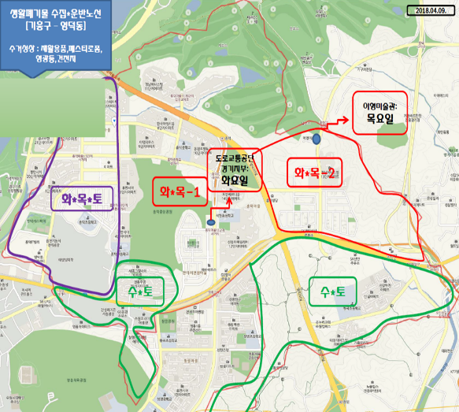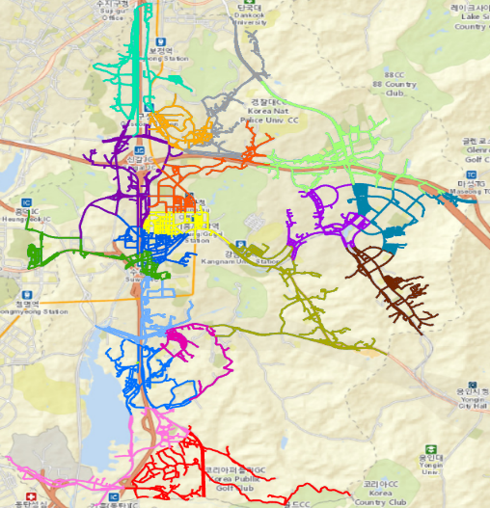This method calculates the difference between the values before and after the improvement, and divides the average of these values by the standard deviation. If the value obtained exceeds 1, it determines as equivalence. The average difference of workload between the existing one and improved one for each vehicle was 461 and the standard deviation was 418. Therefore, it is determined that the workload was equalized because the SI value was 1.10 which is more than 1.

+

Figure 10. Modification Zone

Figure 11. Dividing zones based on administrative districts

## Ⅳ. B Modification the Path

The results of an algorithm performance evaluation are as follows to determine the near-optimized solution using the 2 phase algorithm shown above. Performance evaluation conducted based on 18 divided areas considering that the company works six days a week and owns six vehicles and collect twice a week.

< System environment >

- Version : Windows 10

- System Processor: Intel(R) Core(TM) is-7200U CPU @ 2.50GHz 2.71

- RAM: 8.00GB(7.86GB Available)

- System type: 64bit Operation System, x64 based processor

< Execution Results >

TC : Total Cost / RT : Running Time / Unit : Second

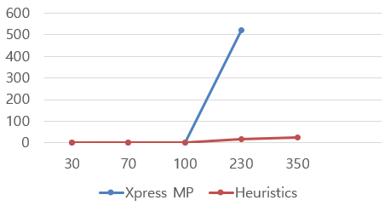Table 3. Compare result between Xpress MP and Algorithm

|  |  |  |  |  |
| --- | --- | --- | --- | --- |
| **Method**  **Num of Arc** | **Xpress MP** | | **Heuristic Algorithm** | |
| **TC** | **RT** | **TC** | **RT** |
| **30** | **1216.3** | **0.172** | **1216.3** | **0.17** |
| **70** | **2596.1** | **0.796** | **2611.6** | **0.2** |
| **100** | **3006.1** | **1.296** | **3600.1** | **0.77** |
| **230** | **15071.7** | **520** | **15105.8** | **16.4** |
| **350** | **15822** | **Over 20minute** | **15954.3** | **24.59** |

Figure 12. Compare RT between Xpress MP and Algorithm

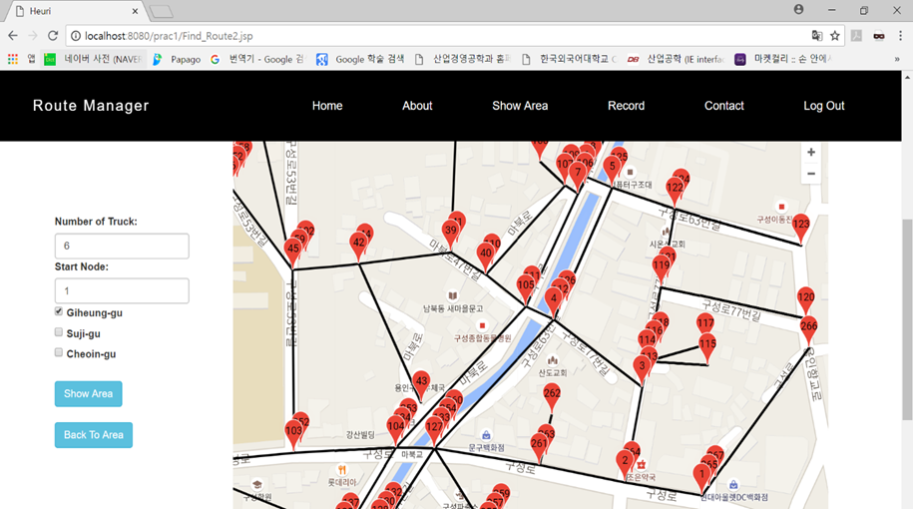 As shown in the above data, 2 phase Algorithm found a similar value to the optimal solution and the RT was much shorter. Therefore, using this algorithm, we searched the routes closed to the optimal route for 18 areas in Giheung-gu, Gyeonggi-do. Among them, the route searched in the area assigned to vehicle number 06** is shown on the google map in the following screen.

Figure 13. Screen for the route

Here the number indicates the order of the visits. If the number is overlapped, it passes the same place once more. Based on the weekly workload, the total cost (time) reduced from 2,930 minutes to 2,646 minutes after improvement. 284 minutes reduced in total.

# Conclusion

This study utilizes the GIS and Heuristic algorithms to modify the collection area to equalize the workload and route to reduce recycling waste collection time. The ultimate purpose is to secure available vehicles and personnel and eventually provides better collection services. To do so, the current collection status and collection method were first identified, and we defined the newly definition of workload. GPS was attached to the vehicle to collect data related to the collection time. Next, the ArcGIS program was used to process this data into appropriate forms and other data needed for analysis was pre-processed. Based on this, regression, clustering, and neural network analysis were performed with statistical analysis to establish a collection time prediction model. But the data obtained were not sufficient enough to establish a meaningful model for predicting the collection time. However, we established 18 new zones using preprocessed data and SKATER algorithms to equalize the workload of employees, which had been a big problem for the company. In addition, it is verified using Smoothness Index that results in a SI value is higher than 1, explaining the workload equality. Then, a We used heuristic Algorithm consisting of 2 Phase to obtain a route for waste collection that was close to the shortest route within the modified zone. A mathematical model was created to verify the performance of the algorithm and compared with the results obtained using the algorithm. As the number of arches increased, the 2phased algorithm's Run Time was significantly shorter than the mathematical model with a near optimal value. In addition, under the existing route, each vehicle worked an average of 3,143 minutes. But it reduced to an average of 2,681 minutes when the route was modified using the algorithm. We constructed a web page to make these findings more intuitive. Through this page, we can check the newly established area and the collection route within the area visually based on Google Maps. We delivered these results to the company and received feedback that although they were slightly different from reality, they would be a good base for understanding the company's status and making future plans.

The modification of the collection also considered spatial adjacency, so it can be not only reduces workers' complaints by providing areas which the workload of all workers is similar but also more efficient in terms of management. Modifying the collection route closer to the optimum can minimize the loss of work time due to movement of workers who are not familiar with geographical information in the area and reduce oil cost. Ultimately, quality of environmental cleanliness services in cities is expected to be improved by efficient use of resources.

The failure to collect the data of factor that affect actual waste collection time in this study remains a great pity. In order to apply in real situation, it was necessary to consider and reflect as much of the reality factor as possible. But there were some limitations particularly in estimating workload because there were many variables in road situations. More and more accurate data and variables are expected in this study to provide a model that can better explain the real world. Further, a more efficient collection management system could be established if the study on schedule management of collection work is carried out on the basis of these data and research results.

**Reference**

Hee-Yeon Lee & Eun-sun Im, “A Study on the Solid Waste Collection Districting and Vehicle routing-Scheduling for Waste Collection Using GIS”, The Journal of GIS Association of Korea, Vol9(2001), pp. 15~30

Angel Corberan & Gilbert Laporte, *Arc Routing Problems, Methods, and Applications*, SIAM(January 8, 2015). pp. 65~73

Byung-In Kim and Seong bae Kim and Surya Sahoo, “Waste collection vehicle routing problem with time windows”

Jeroen Beliën and Liesje De Boeck and Jonas Van Ackere, “Municipal Solid Waste Collection Problems etc regarding 7 thesis in total” (2011)

NB Chang and HY Lu, YL Wei, “GIS technology for vehicle routing and scheduling in solid waste collection systems”, Journal of environmental engineering(1997)

**Appendix and Index**

System Functional Description

1. First screen

- The screen when first entering the homepage.

Figure. First Page

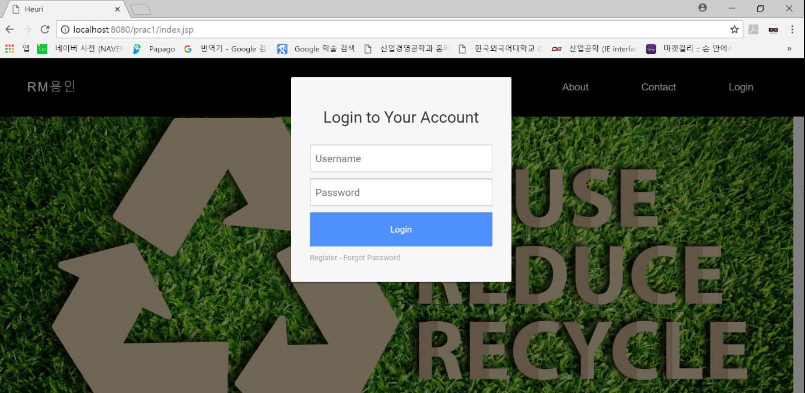2. Log-in Page

Figure. Log-in Page

A login is required to use the function to check the area modified by ArcGis and modify a path closer to the optimum. If the user information stored in the DB matches, it goes to the next screen.

3. After Log-in page

Figure. After Log-in page

Once logged in, you can see that the 'Show Area' function has been created in the menu.

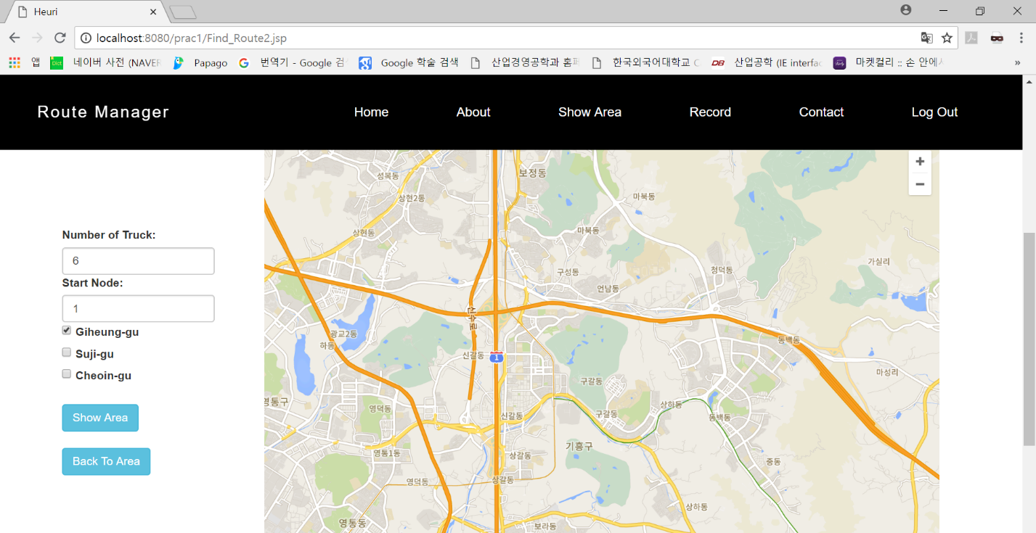4-1. Checking the Modified Zone

Figure. Screen for Checking Modified Zone

Click 'Show Area' to check the divided area and the screen will appear as follows.

There are a total of six trucks assigned to Giheung-gu, and the set starting point '1' as shown on the next screen.

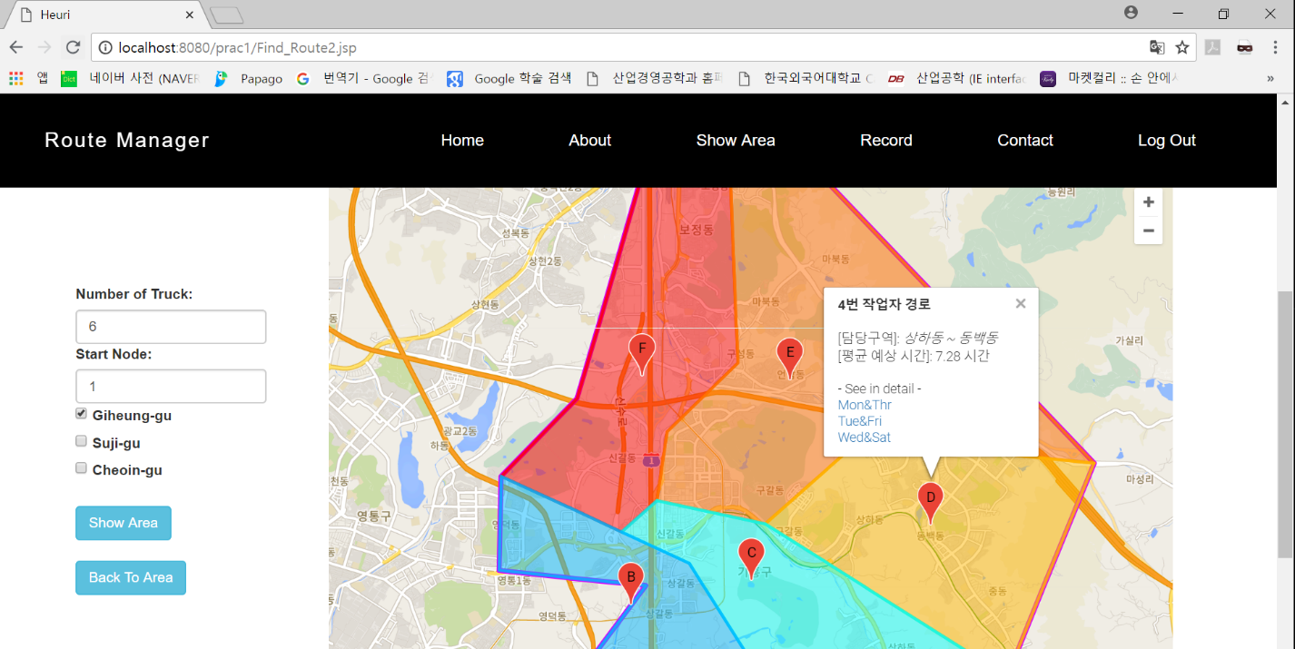4-2 Checking the Modified Zone

Figure. Screen for Checking Modified Zone

The entire Giheung-gu area is surrounded by a red rim,. Six areas were divided into colors. Workers are assigned to each zone, for example, if you click on Zone D, worker No. 4 is in charge, and the area in charge is Sangha-dong and Dongbaek-dong. In addition, the average estimated time was set to the total time taken to move the route while working. As shown in the picture above, one area was divided into three locations, arbitrarily dividing them into Mondays & Thursdays, Tuesdays & Fridays and Wednesdays & Saturdays to indicate that each site works on average twice a week.

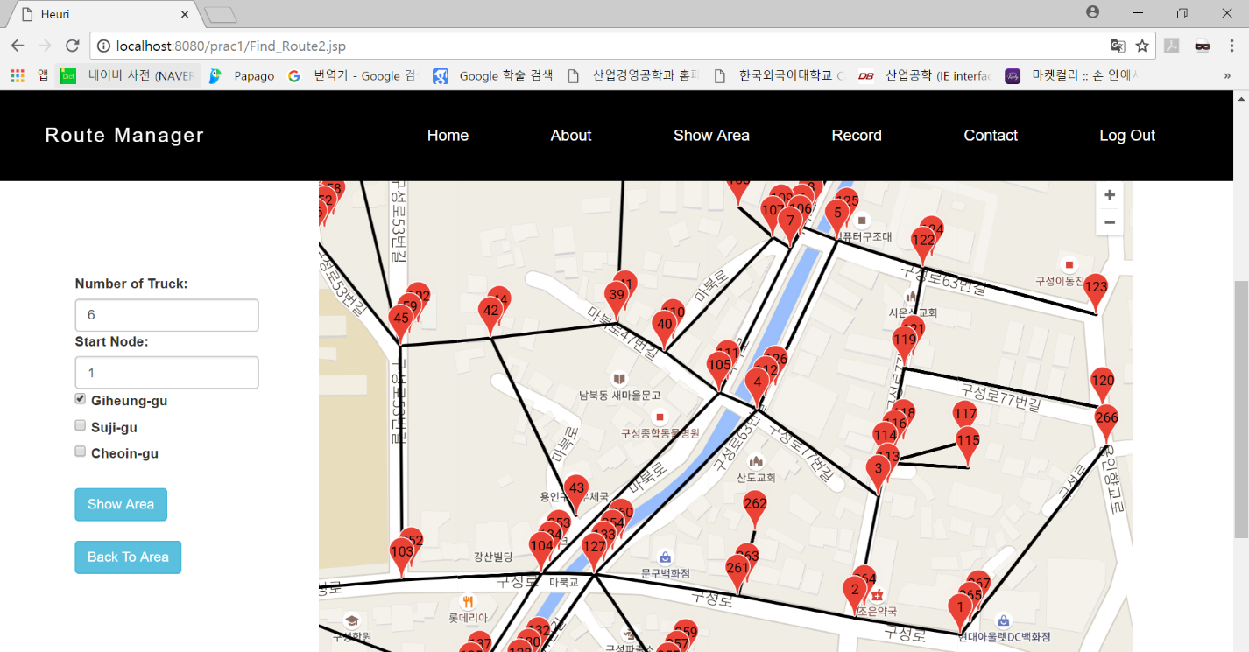5. Checking detail route

Figure. Screen for detail route

When the areas divided as shown above are divided into three (Monday & Thursday, Tuesday & Friday, and Wednesday & Saturday), click on them to find out the detailed route on Monday & Thursday to run a routing algorithm implemented in pythons using the input data of arc to view the following screen: Since the starting point is number 1 and all arcs are moved, numbers are used to indicate their direction, which is expressed as moving directly to the next number. A place where two or more numbers are expressed in one place overlaps the past. If you want to check other paths or areas, click ‘Back To Area’ on the left side of the screen to return to the original screen.

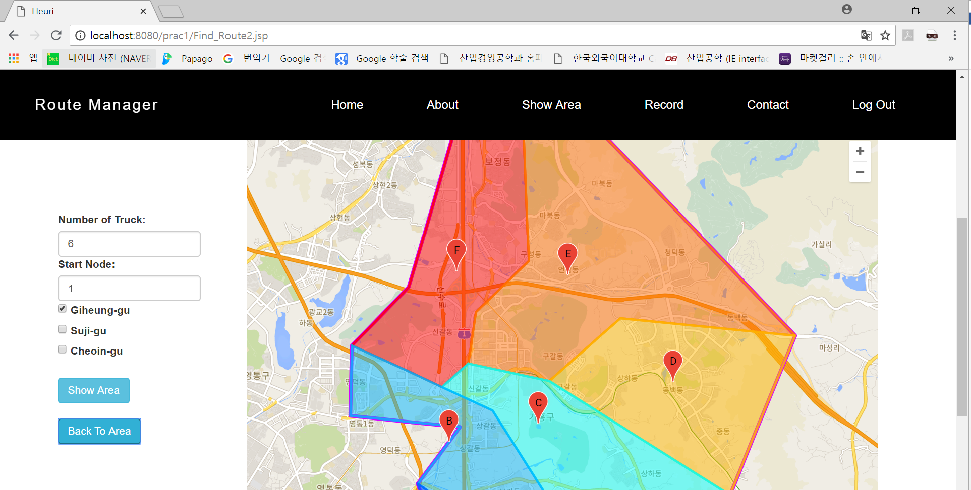Figure. Returned to Zone Modification Screen